SYMMETRY
OCR Thursday 7 June 2018 – Morning (Non Calculator) Foundation Tier

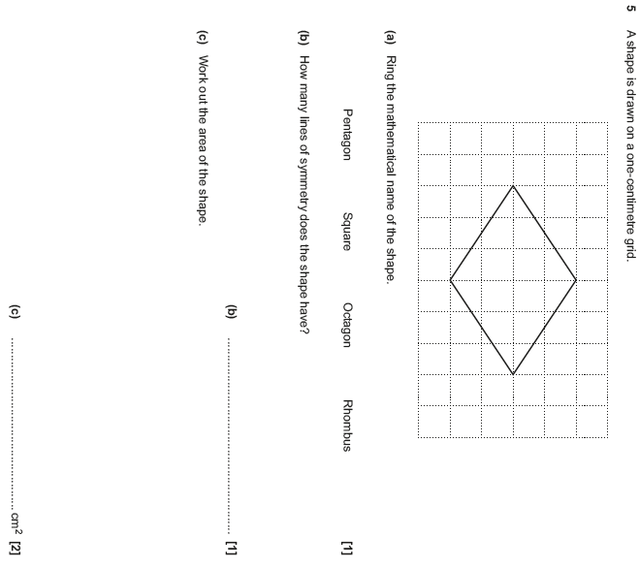

OCR Tuesday 12 June 2018– Morning (Calculator) Foundation Tier
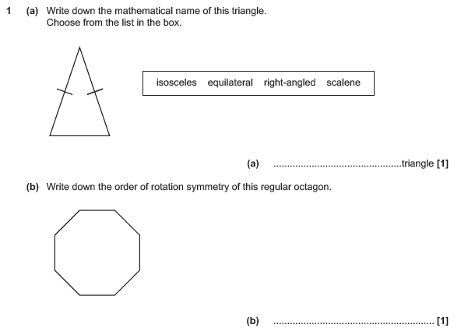

OCR Monday 6 November 2017– Morning (Calculator) Foundation Tier
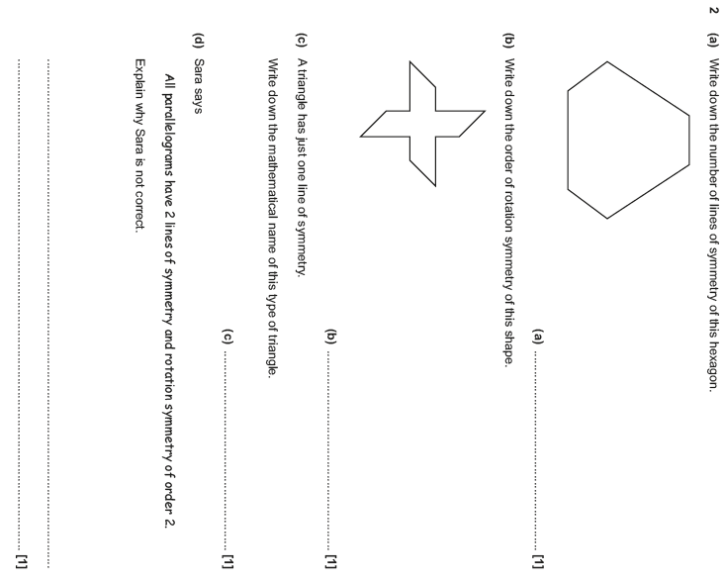

AQA Thursday 11 June 2019 – Morning (Calculator) Foundation Tier

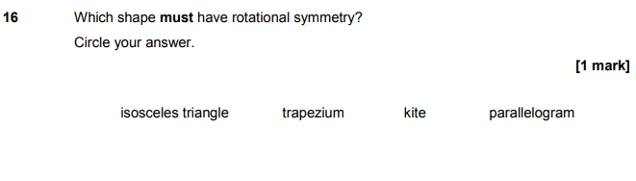
AQA Monday 12 November 2018 – Morning (Calculator) Foundation Tier

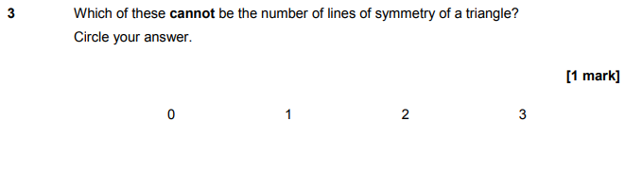

AQA Thursday 7 June 2018 – Morning (Calculator) Foundation Tier

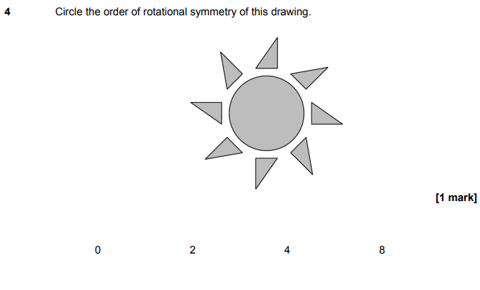
AQA Tuesday 12 June 2018 – Morning (Calculator) Foundation Tier

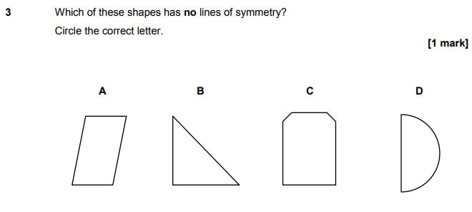

AQA Thursday 2 November 2017 – Morning (Non-Calculator) Foundation Tier

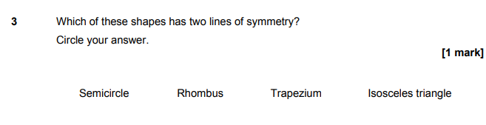
AQA Sample Paper 3– Morning (Calculator) Foundation Tier

